Discriminative and Generative models;

class 5

Jea Yun Jun Kim

E2 P423

[jae-yun.jun-kim@ece.fr](mailto:jae-yun.jun-kim@ece.fr)

Reminder :

SSE = sum of square error

R²

MSE = mean of squared error

Overfitting : overspecify → model complexity > problem complexity

Underfitting : model complexity < problem complexity

Just fitted : model complexity = problem complexity

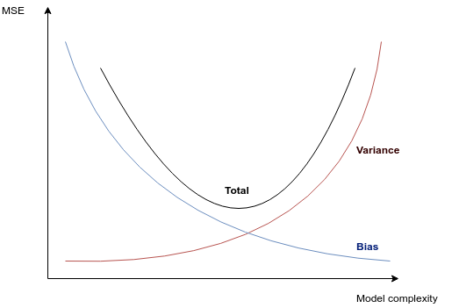

Resolving overfitting :

**going ← :** reducing number of features/parameters

**going down** : keeping the complexity of model with regularization

### Discriminative and generative models :

(instead of SL, UL, RL)

|  |  |
| --- | --- |
| **Discriminative models (DM)** P( Y|X ) ? | **Generative models** P( X,Y ) ? |
| 1. represent the dependence of unobserved (target) variables y on observed variables X. 2. infer outputs (y) based on inputs(X), given some hidden parameters (θ) 3. do not care about how the data (X) was generated | 1. generate all values both those that can be observed (y) (target) and those that can only be computed from the observed ones (X) 2. have as goal :    1. modeling data (X) directly P(X)?    2. an intermediate step to forming **conditional probability function** using the **Bayes rule**. P( y|X ) ? 3. estimate how the data (X) was generated   Generative models are more powerful |

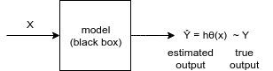

### Bayes Rule :

* Discriminative :
  + P( X,Y ) = P( Y|X )P(X)
  + P( Y|X ) = $\frac{P(X,Y)}{P(Y)}$
* Generative :
  + P(Y,X) = P( X|Y )P(Y)
  + P( X|Y ) = $\frac{P(X|Y)P(Y)}{P(X)}$

## Lab :

**Bernouilli :**

* can take only 2 values : 0 or 1. ⇒ HW

**Multinomial :**

* can take several values [0, M] ⇒ M+1 values

## Homework :

**Bernouilli Naive Bayes :** we have to implement it ourselves.

⇒ takes continue values

**.fit** ⇒ trains the I/O data the model. Train = finds the optimal parameters.

**.predict** ⇒ to find Ŷ of the trained data

N : number of train samples

I : number of input variables/features

parameter = model

X = input model

size = (I,N)

**Gaussian Naive Bayes =** random values

⇒ X : continue values

⇒ Y : discrete values

* Gaussian always takes continue values. Applied to X.